Presentation of the school using digital technologies

Elementary school Újezd ​​u Brno, Brno-venkov district, contribution organization
School 284
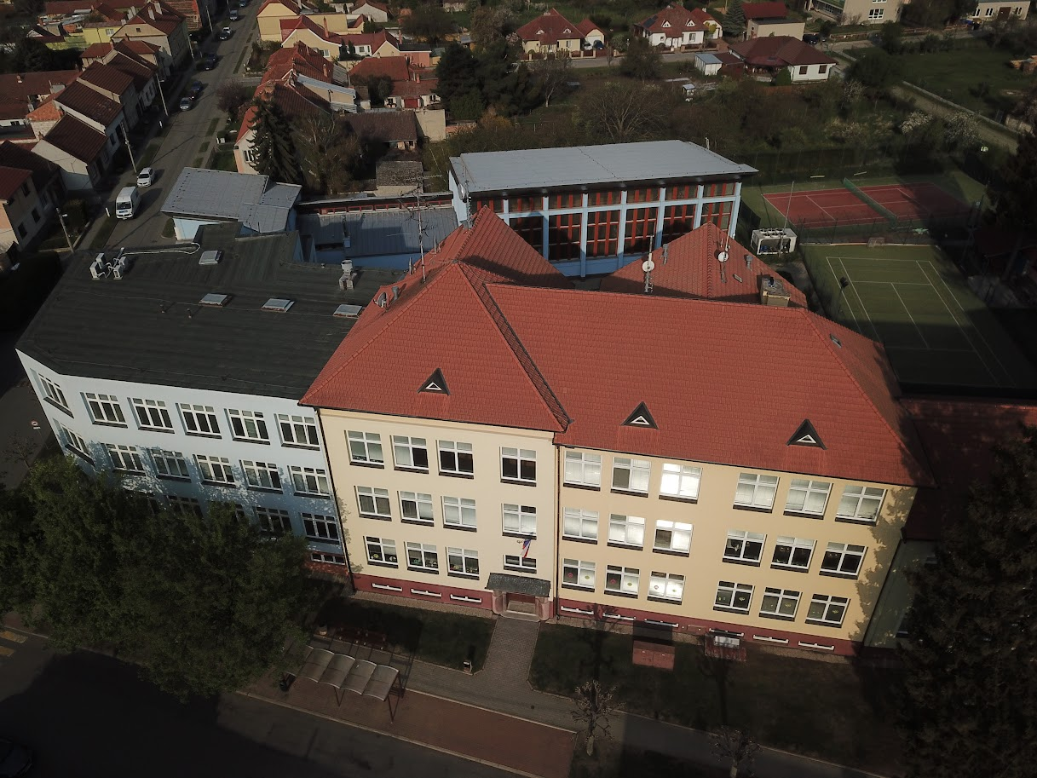

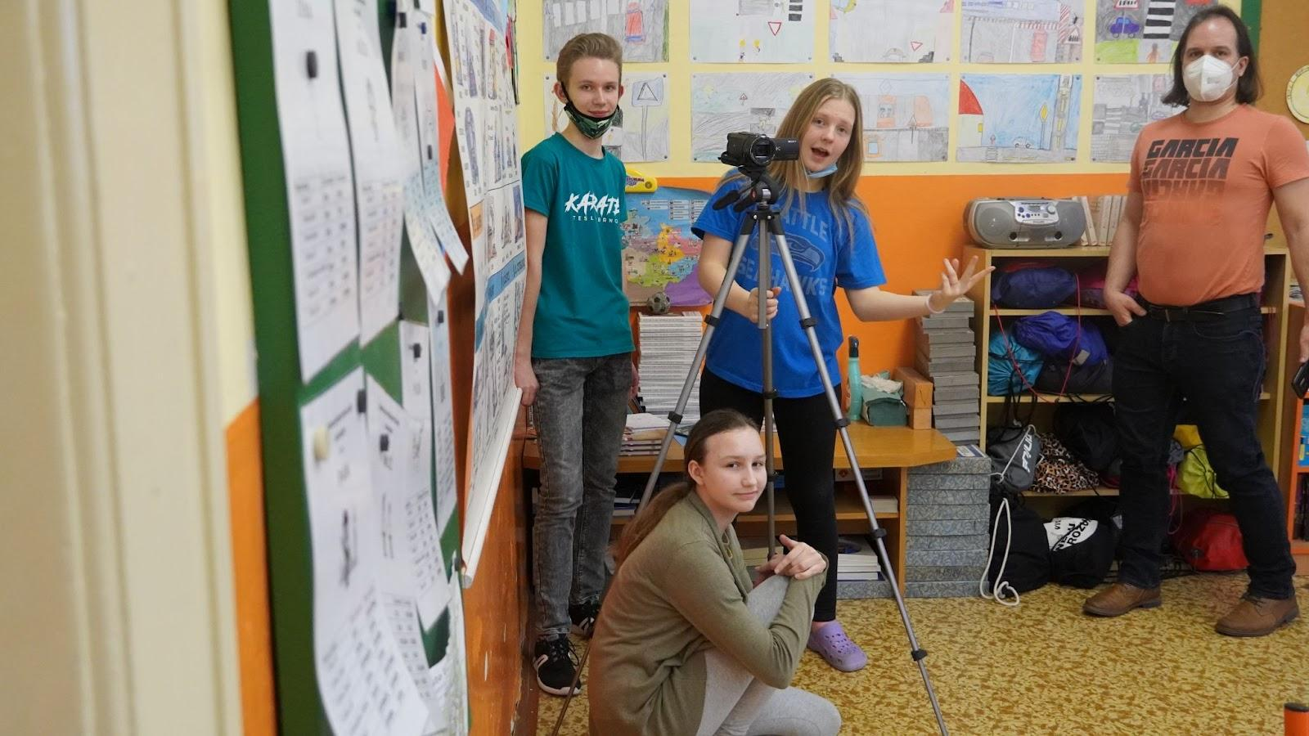
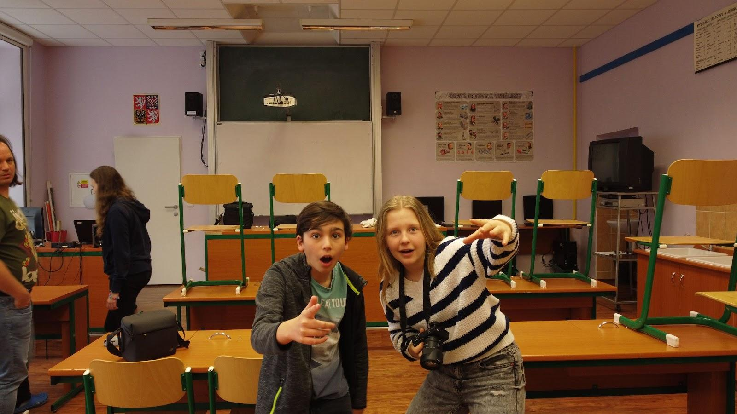

Content
Project information 5
Project description 5
Age category 5
What skills should students master before starting the project? 5
What skills will the students learn as part of the project: 5
Material equipment needed to implement the project 6
Device 6
Evaluation of equipment 8
Financial difficulty 8
Basic equipment 8
3d Printer 9
Drone 10
Asus laptop 11
Camera, camera and GoPro camera 11
Creating a promo video about the school 12
The process of creation 12
Virtual tour of the school 15
Explanation 15
School website 15
Creation of a new school Instagram and Facebook 18
Establishing a school YouTube channel 19
Photo samples of general and specialised classrooms 20
Photos 20
Taking photos of the school using a drone 27
Professional photos from project preparation 28
Work in specialised classrooms 36
Pinnacle Studio 39
Evaluation 39

Project information

Project description
The main content of our project is the enrichment of the new website of our primary school, with the help of modern digital technologies.

Age category
The project is suitable for 8th and 9th grade students within the elementary school. Parts of the project can be used, for example, in computer science lessons at elementary school - as a final student project.

What skills should students master before starting the project?
Basics of video cutting (no knowledge of any specific cutting program is required)
Proficiency in using digital technology e.g. camera, camera,...
The basics of working with a drone.
Ability to work in a team.

What skills will the students learn as part of the project:
Sending data and their further processing.
Working with cutting programs.
Controlling the drone.
Taking photos and videos with a tripod.

Material equipment needed to implement the project

Device

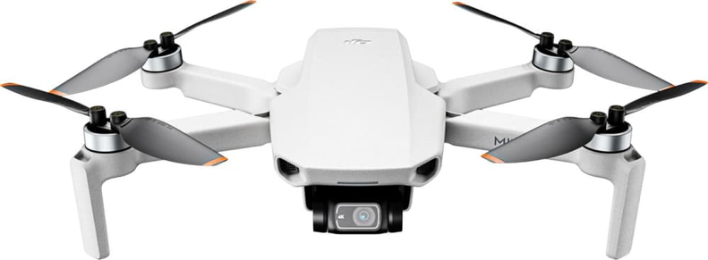
https://dronpro.cz/dron-dji-mini-2-1
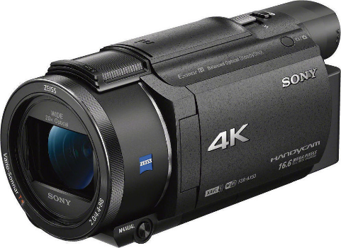
https://www.sony.cz/electronics/videokamery-handycam/fdr-ax5
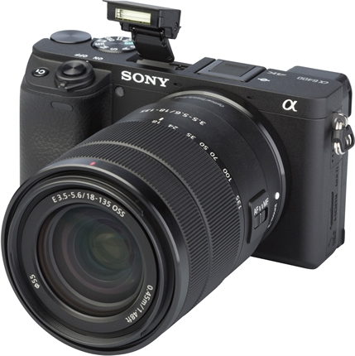
https://www.fotoskoda.cz/sony-alpha-a6400-telo-cerny/
https://www.asus.com/cz/Laptops/For-Gaming/TUF-Gaming/2021-ASUS-TUF-Gaming-F15/
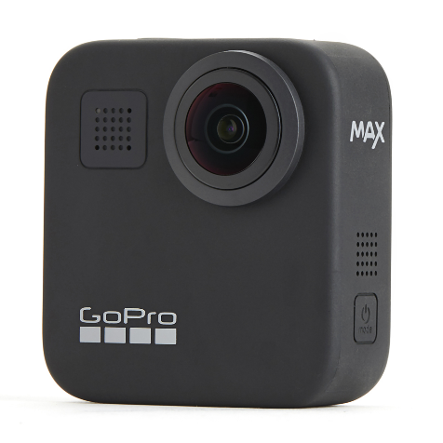

https://gopro.com/en/us/shop/cameras/max/CHDHZ-202-master.html

Evaluation of equipment
We evaluated the purchased equipment positively, but unfortunately one of our colleagues bumped into a tree with the drone while filming, which resulted in a complaint.

Financial difficulty

Basic equipment
We received a large subsidy of up to 100,000 CZK for all devices. All money was honestly used only for technical modern equipment and we thank the whole DigiMe company for this generous contribution.

DJI Dron DJI Mini 2 Fly More Combo šedý | 17 000 Kč | shorturl.at/lsNR2
Sony FDR-AX53 | 27 000 Kč | shorturl.at/oyFV0
Shearing equipment | 2 000 Kč | shorturl.at/jmqFN
ASUS TUF Gaming F15 | 35 000 Kč | shorturl.at/qxW24
Camera tripod | 3 000 Kč | shorturl.at/efhzQ
GoPro Max | 13 000 Kč | shorturl.at/mopxN
Sony battery | 1 900 Kč | shorturl.at/hoMX9
Bag | 1 100 Kč | shorturl.at/guxOR

3d Printer
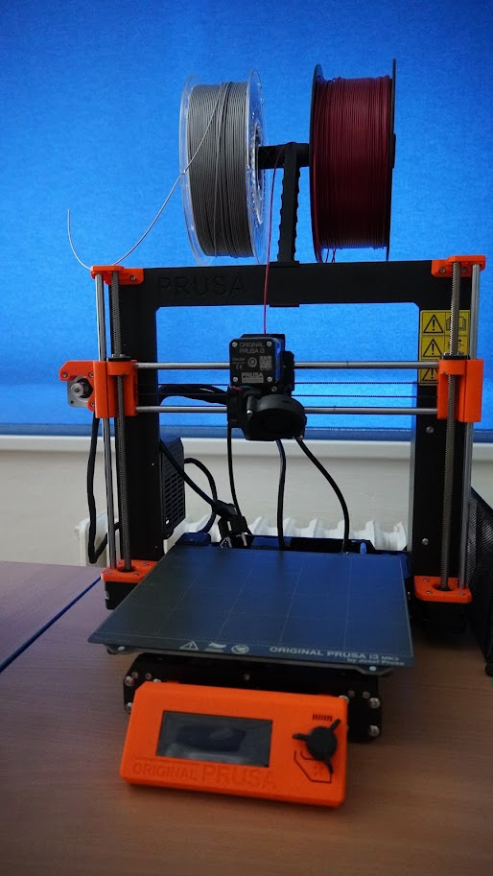
As part of the project, the pupils were introduced to the function and use of a 3D printer, not only thanks to a presentation organised as part of the project by two external workers from the DigiMe project, who introduced the pupils to this device, which is in our school's computer science classroom. The printer was used not only within the project, but thanks to it we have produced, for example, name tags on the doors of teachers' offices and classrooms.

Drone
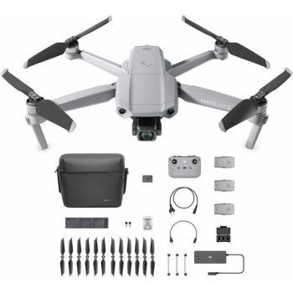
As another piece of technical equipment, we were allowed to familiarise ourselves with the drone as part of the project. We mainly used it to film a virtual tour of the school and shots from a greater height, such as the school from a bird's eye view or other additional shots, for example from the school gymnasium etc.

Asus laptop
It was used for saving, cutting photos and videos.

Camera, camera and GoPro camera
The device was designed for taking photos and video recording.

Creating a promo video about the school
The process of creation
One of our tasks was to create a promotional informational video about our school. The video was created with the help of our digital smart devices obtained from the DigiMe grant. For example, the drone with which we filmed the school from above, or the camera was for example used to record lessons etc.
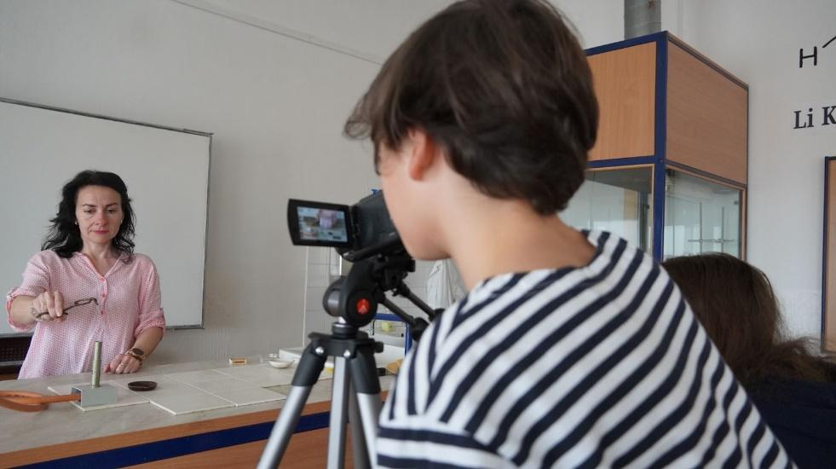
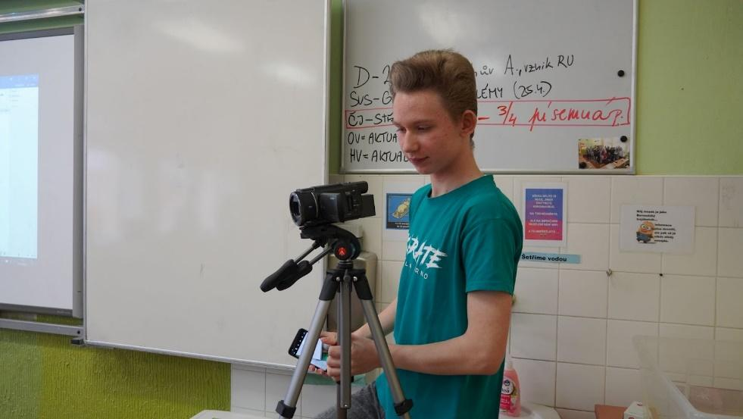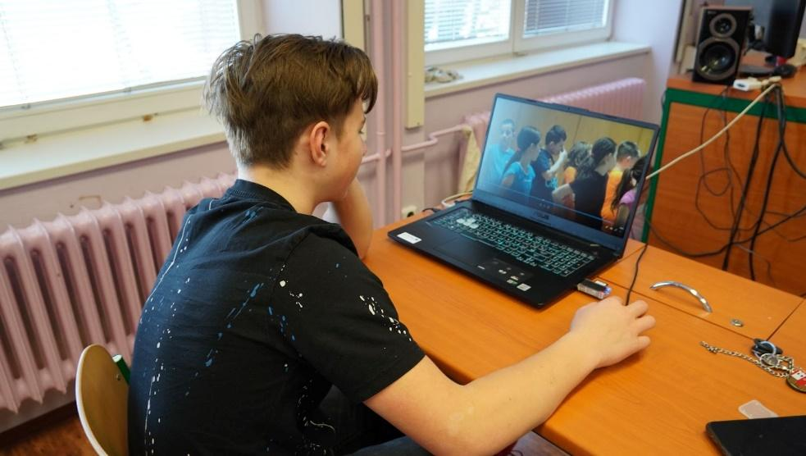
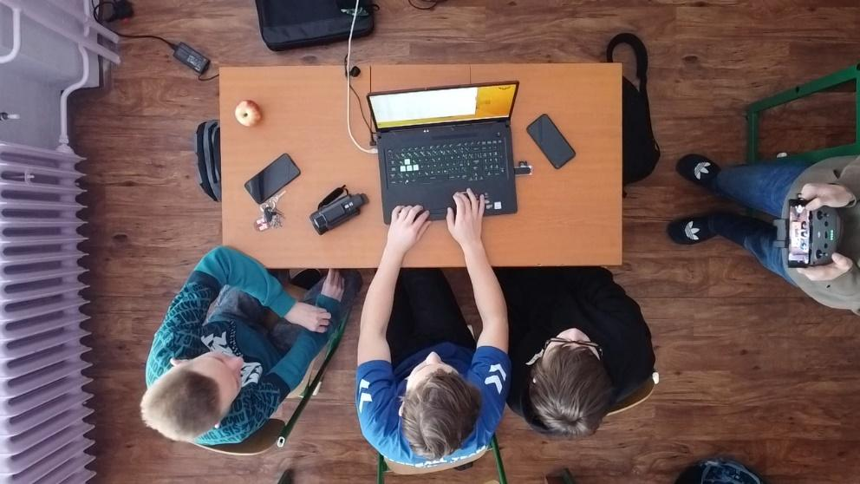
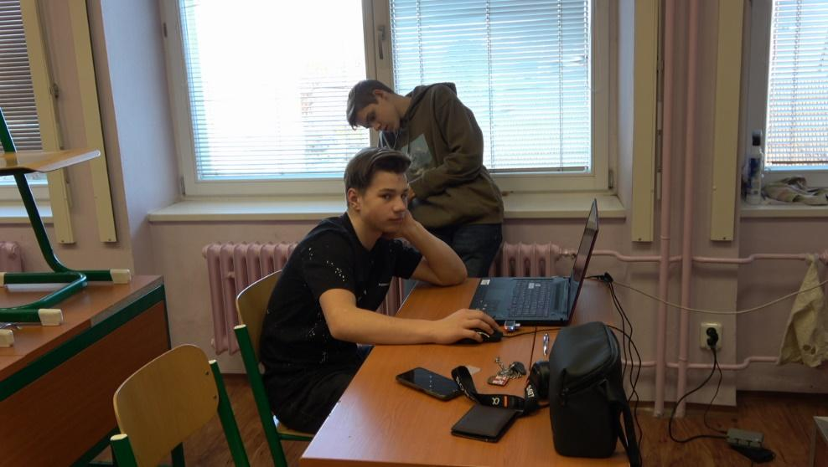
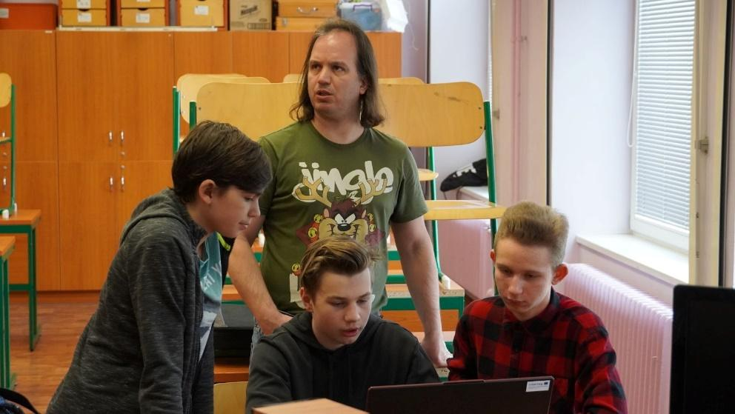

Virtual tour of the school

Explanation
As part of the project, we started a virtual tour of the school, due to the rebuilding of the school. The whole school had to be cleaned and adjusted to make it look presentable. Our grant-funded drone was also used.

School website

Original school website:
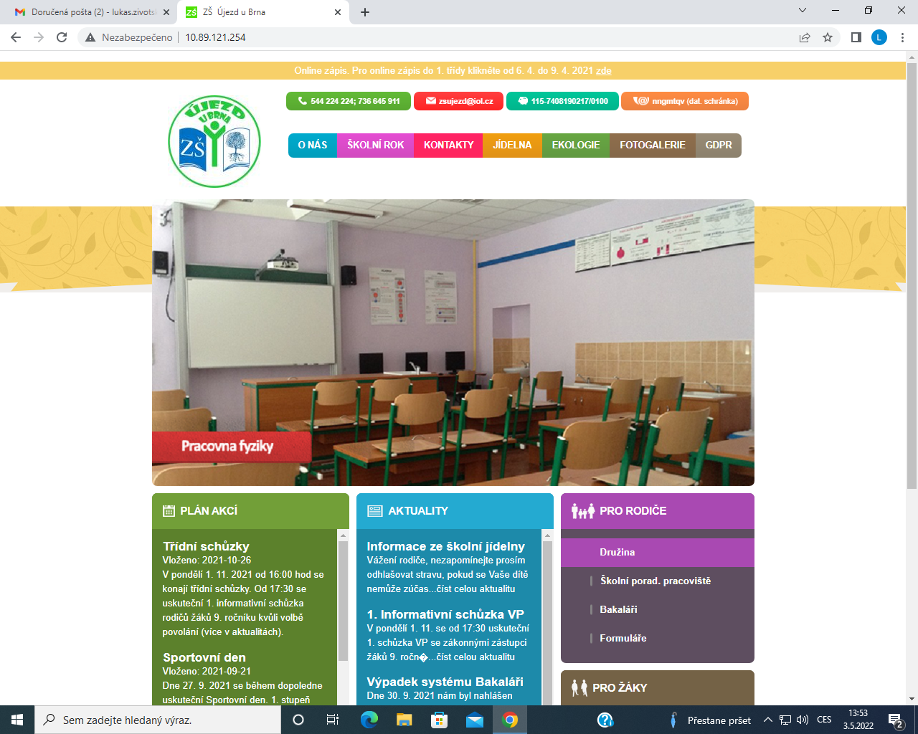

New school website:
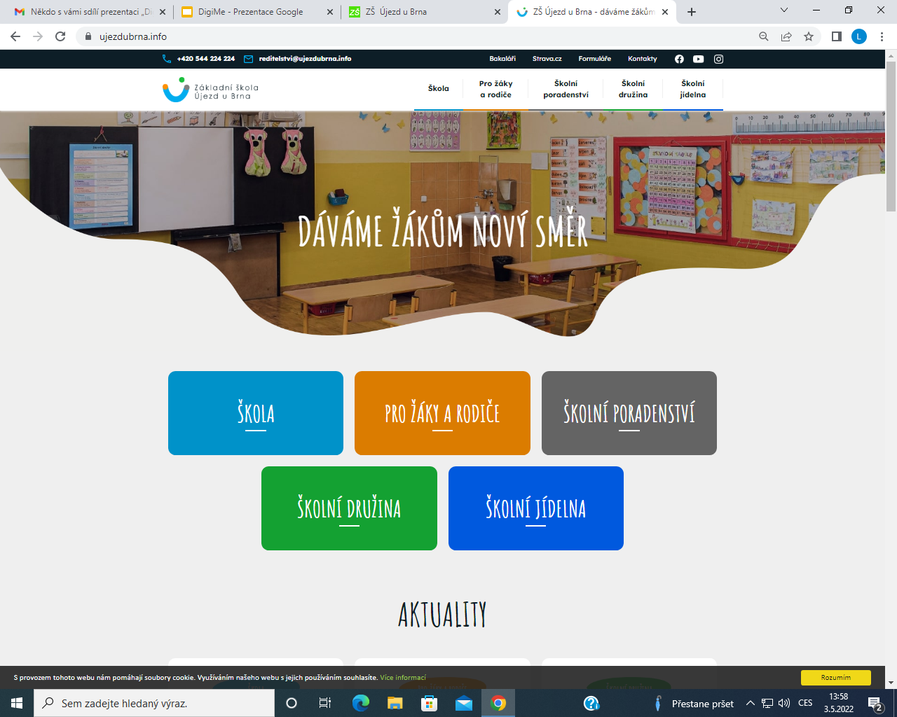
We also updated the school's website graphically

Creation of a new school Instagram and Facebook
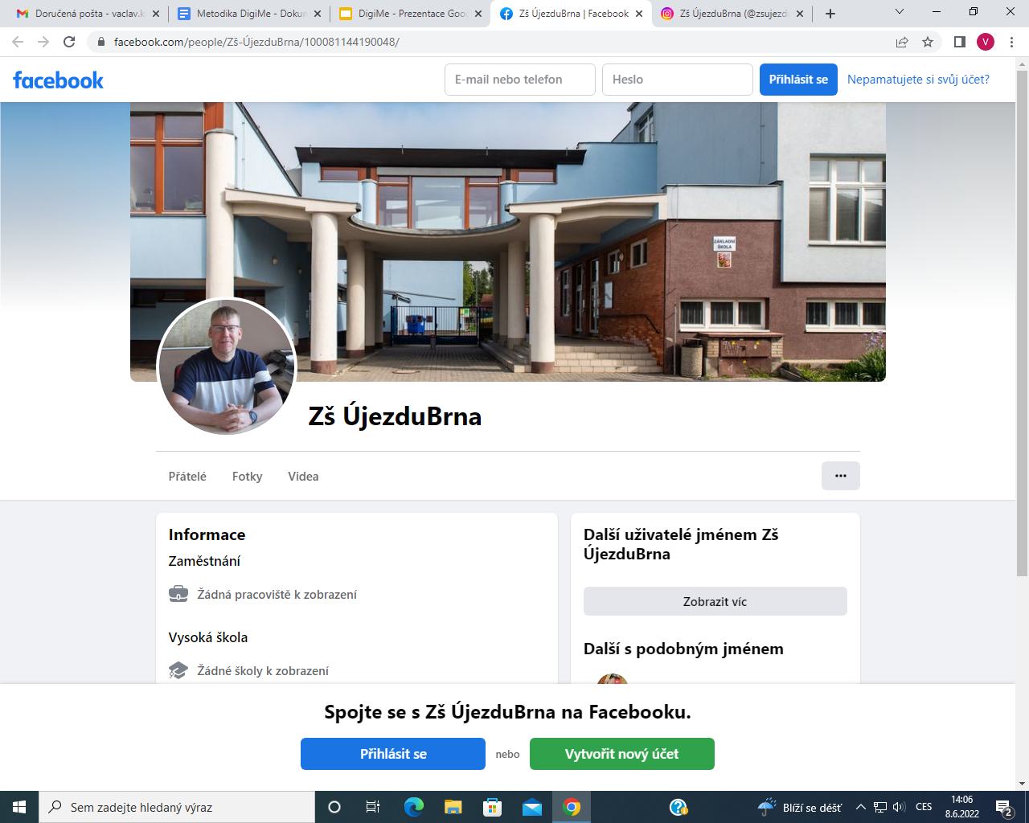

Establishing a school YouTube channel
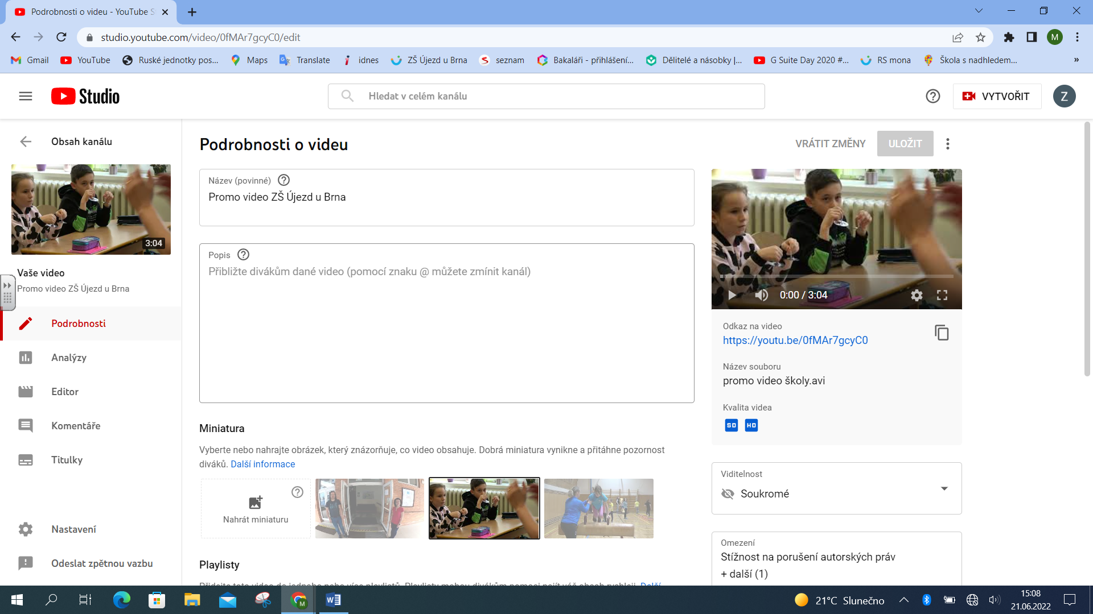

Photo samples of general and specialised classrooms
Photos
First of all, it was necessary to photograph all the general and specialised classrooms. Here are examples of photos from specialised classrooms that were used in the promo video and presentation.

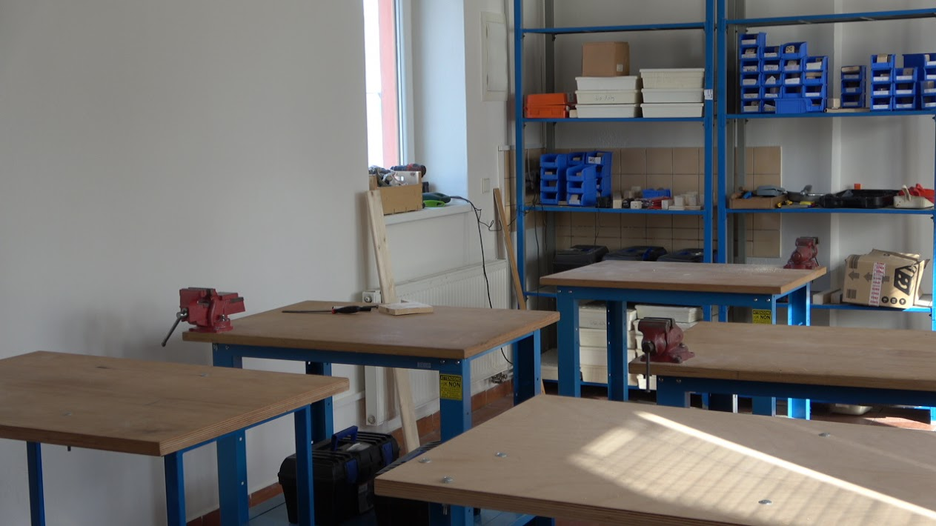
Workroom
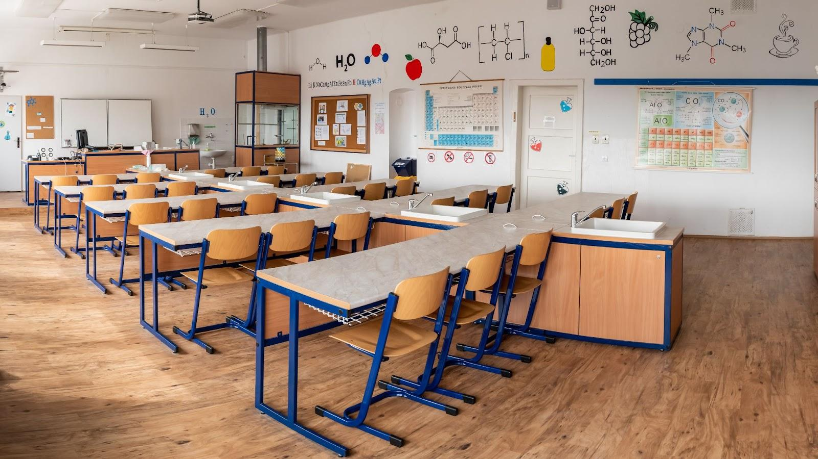
Chemistry
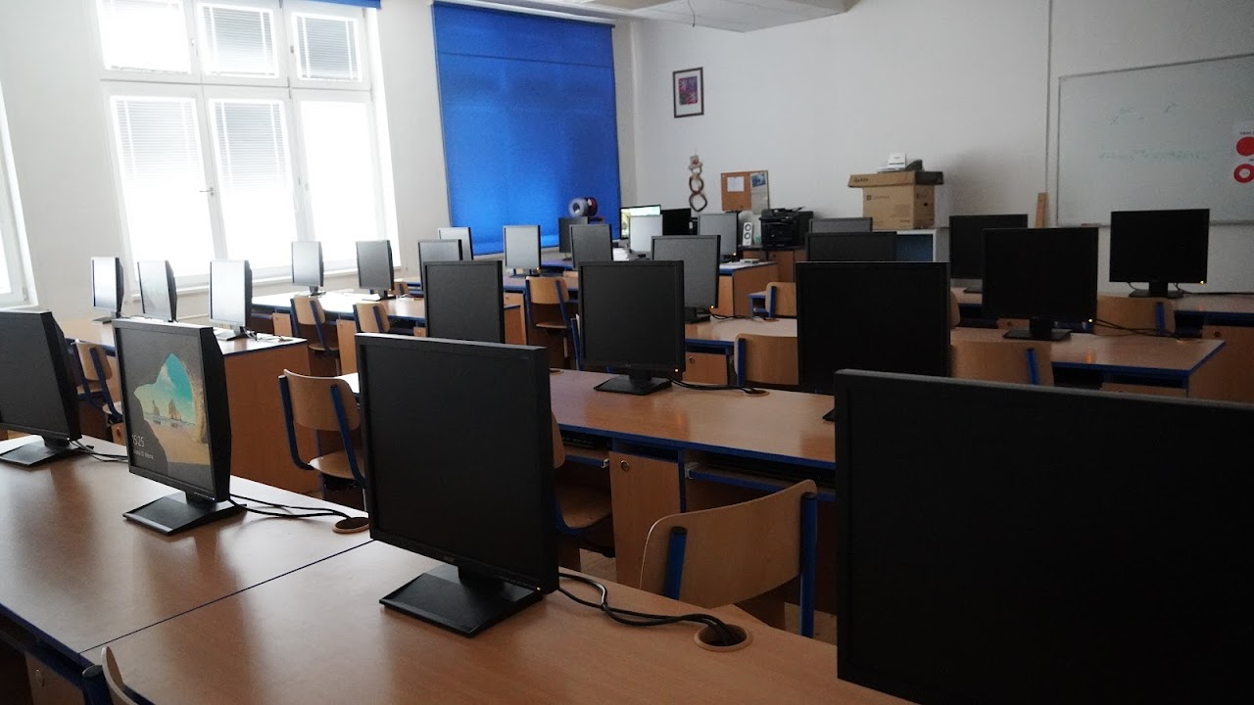
Informatics

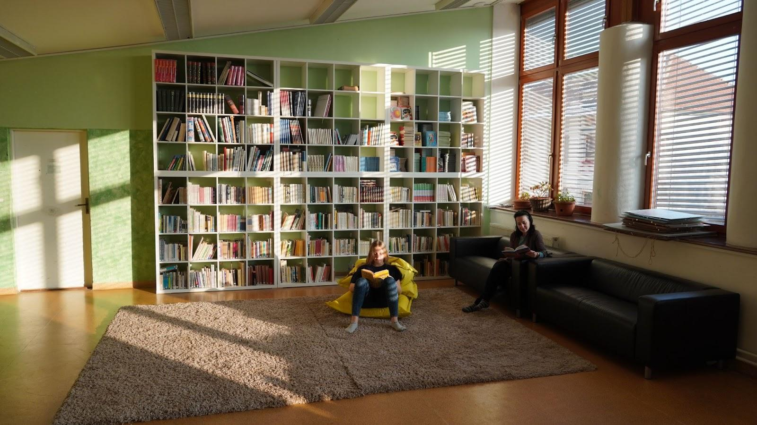
Reading room
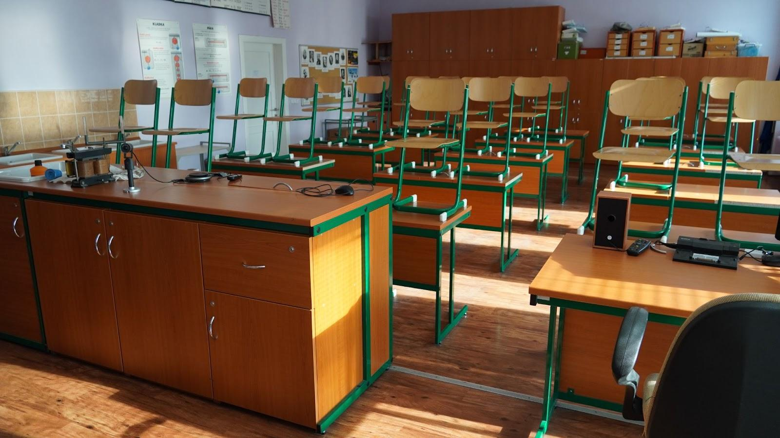Physics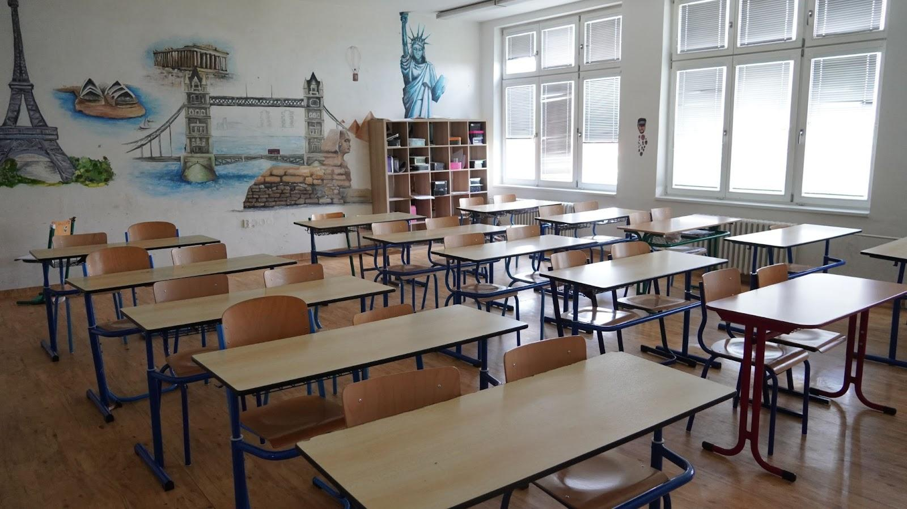Geography

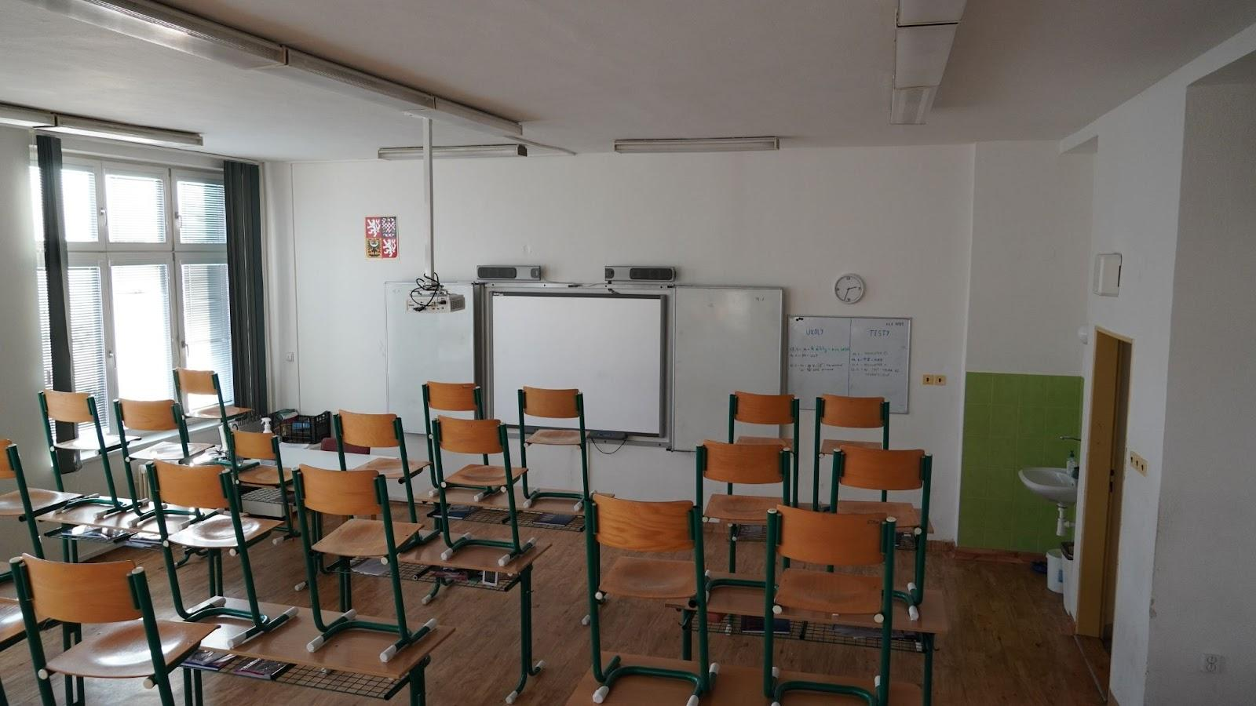
classroom 6.B.
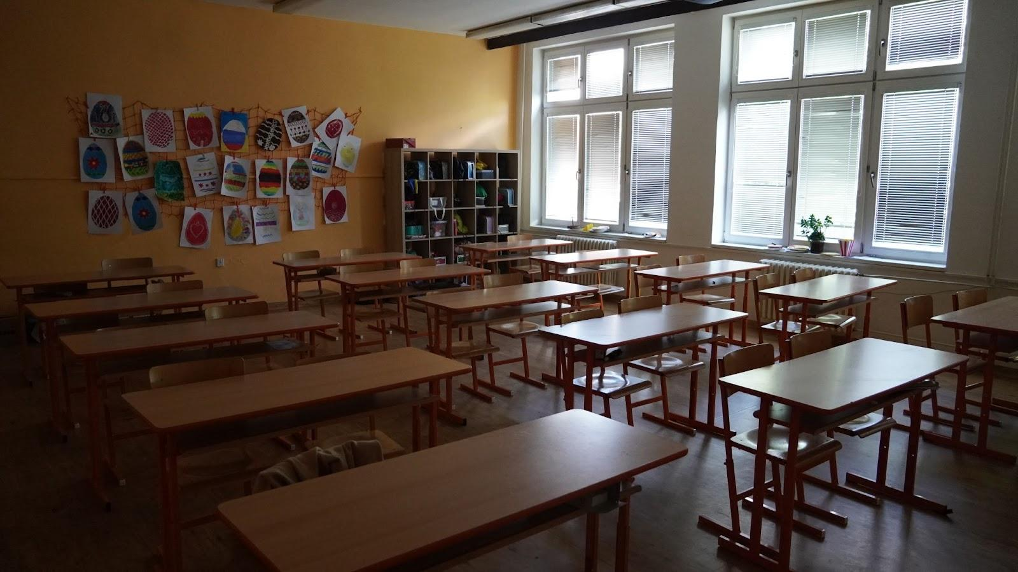
Music classroom
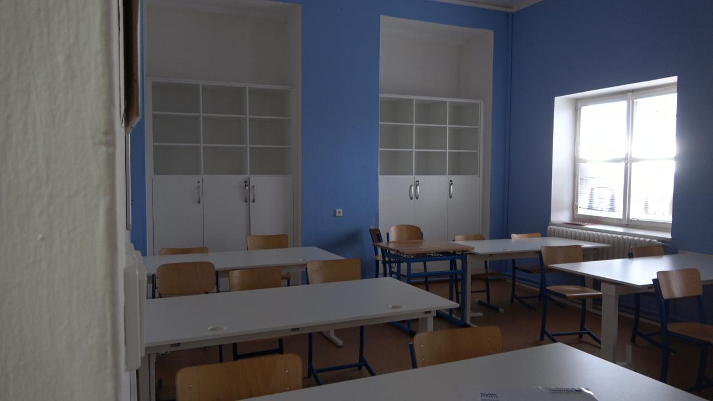 language classroom
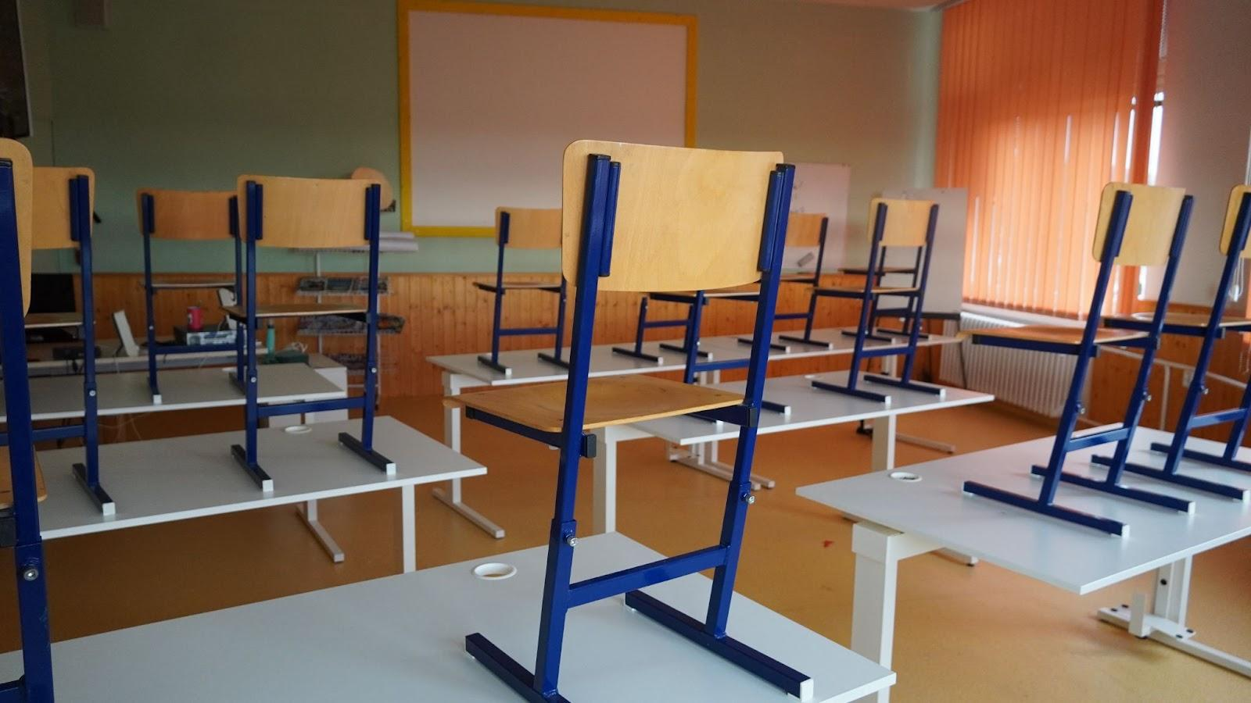
1st classroom
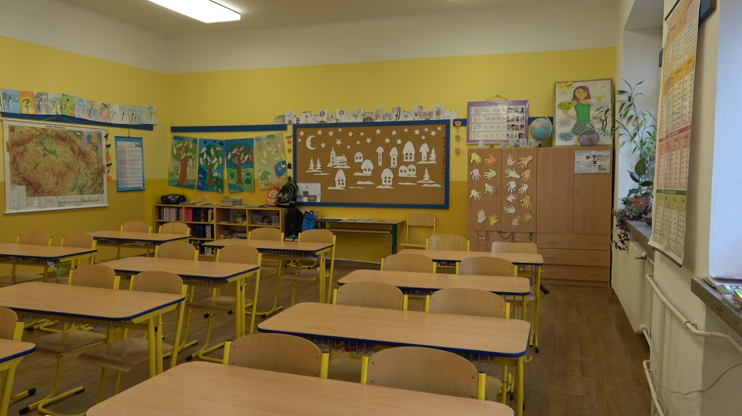
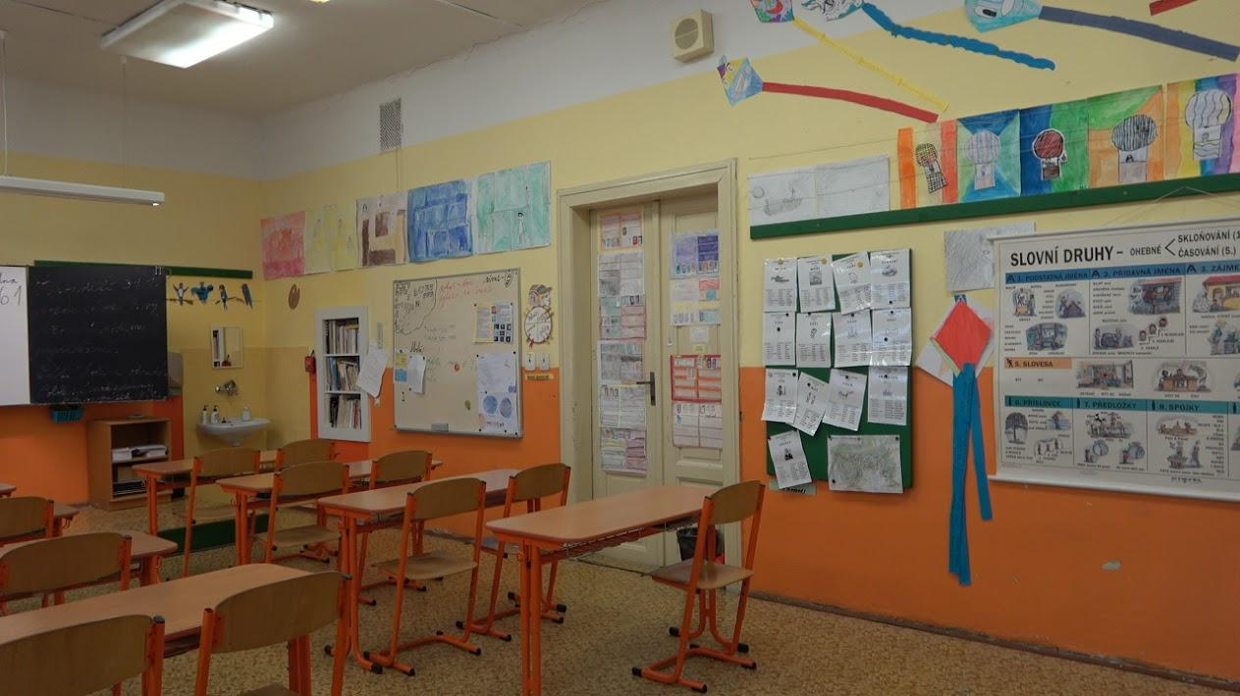

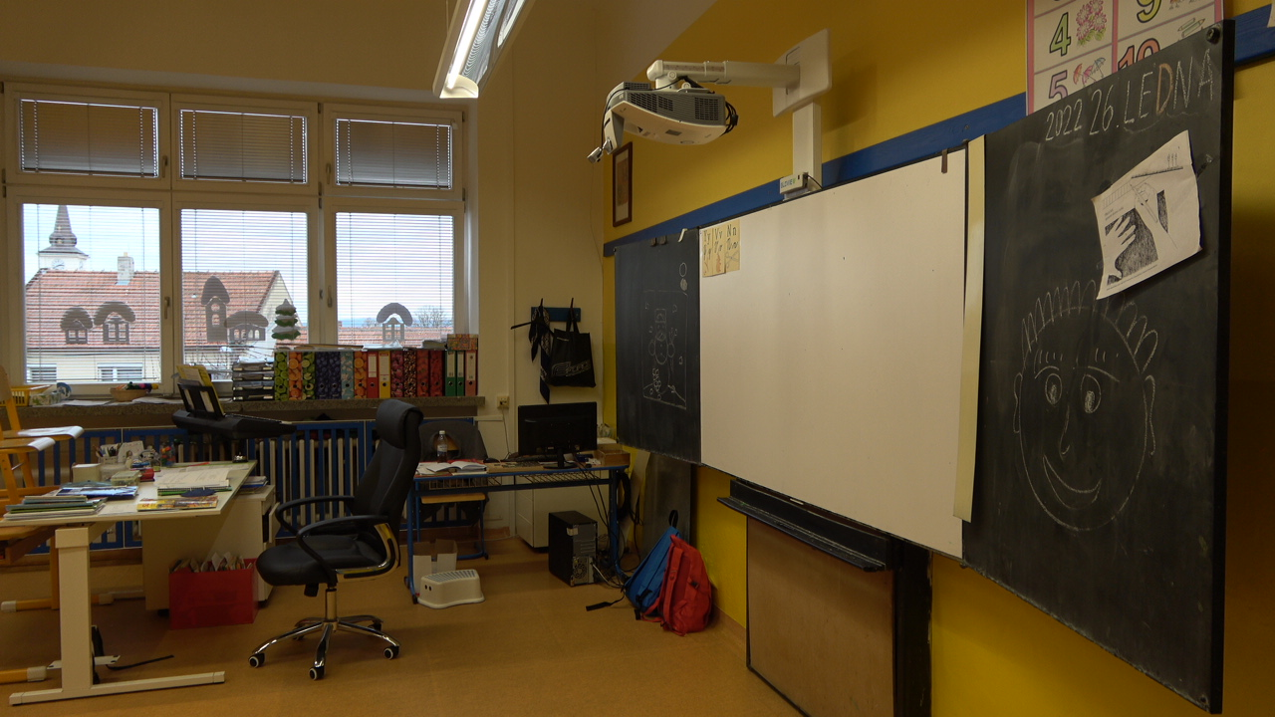

Taking photos of the school using a drone
Because we wanted to include an eagle view in the promo video, we had to use a drone to film and photograph the school very carefully.
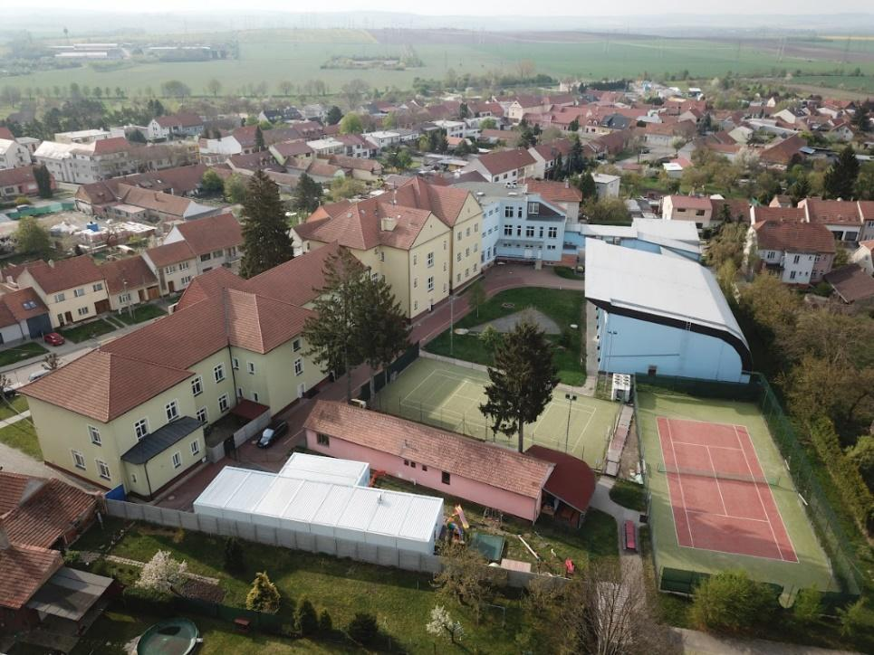
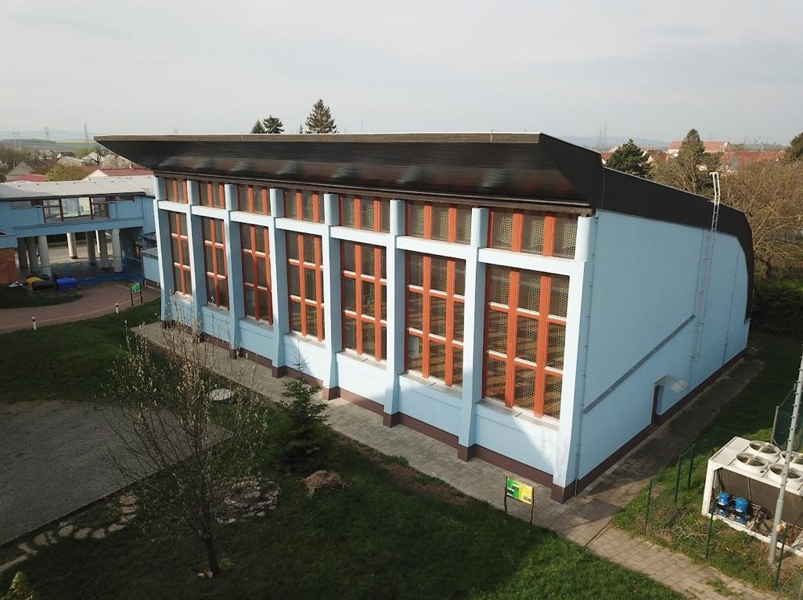

Professional photos from project preparation
Since we got a lot of equipment for taking photos, no one can be surprised that we have a lot of photos of us working with great joy :)

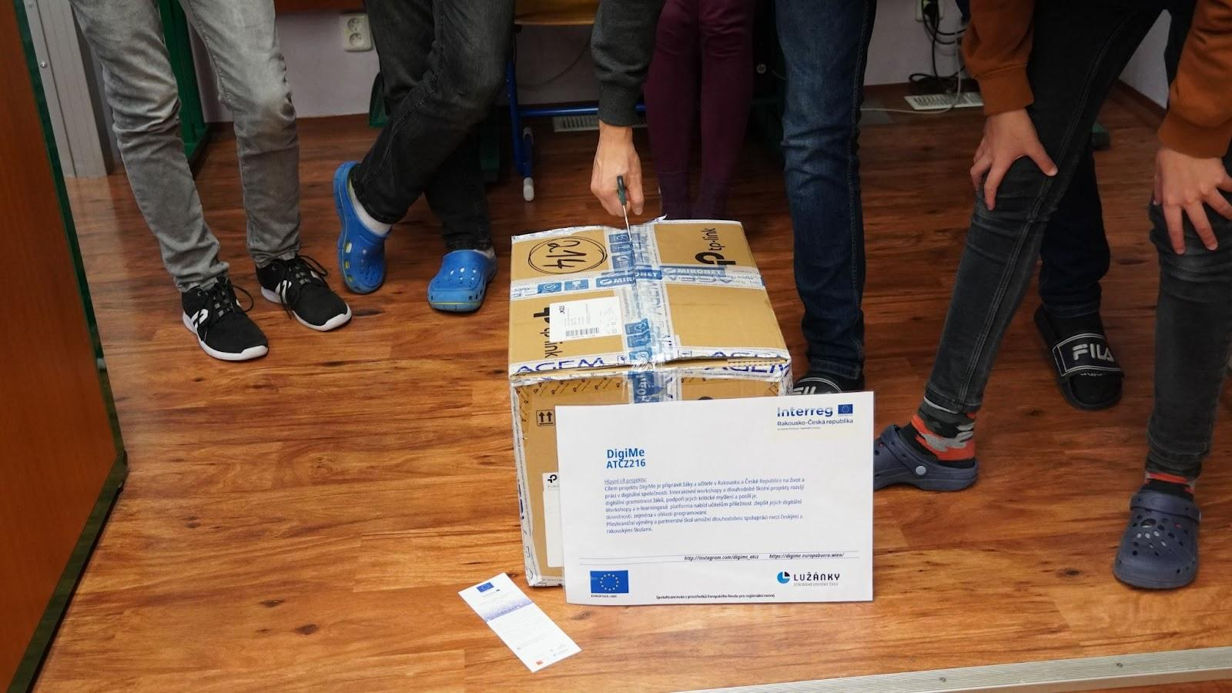
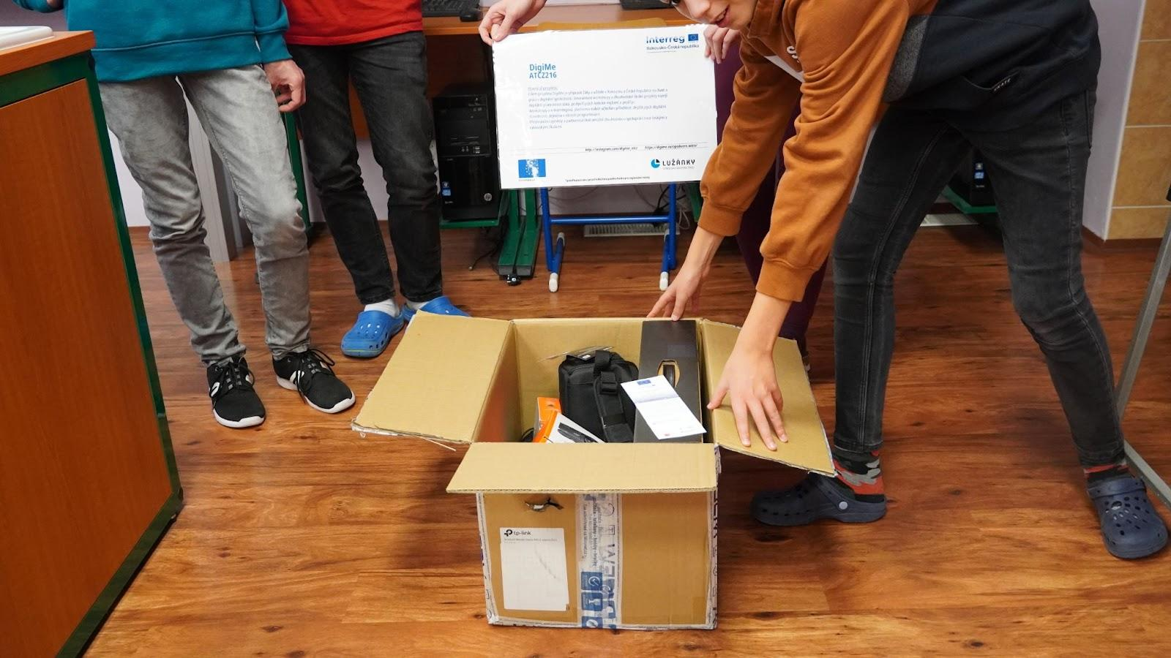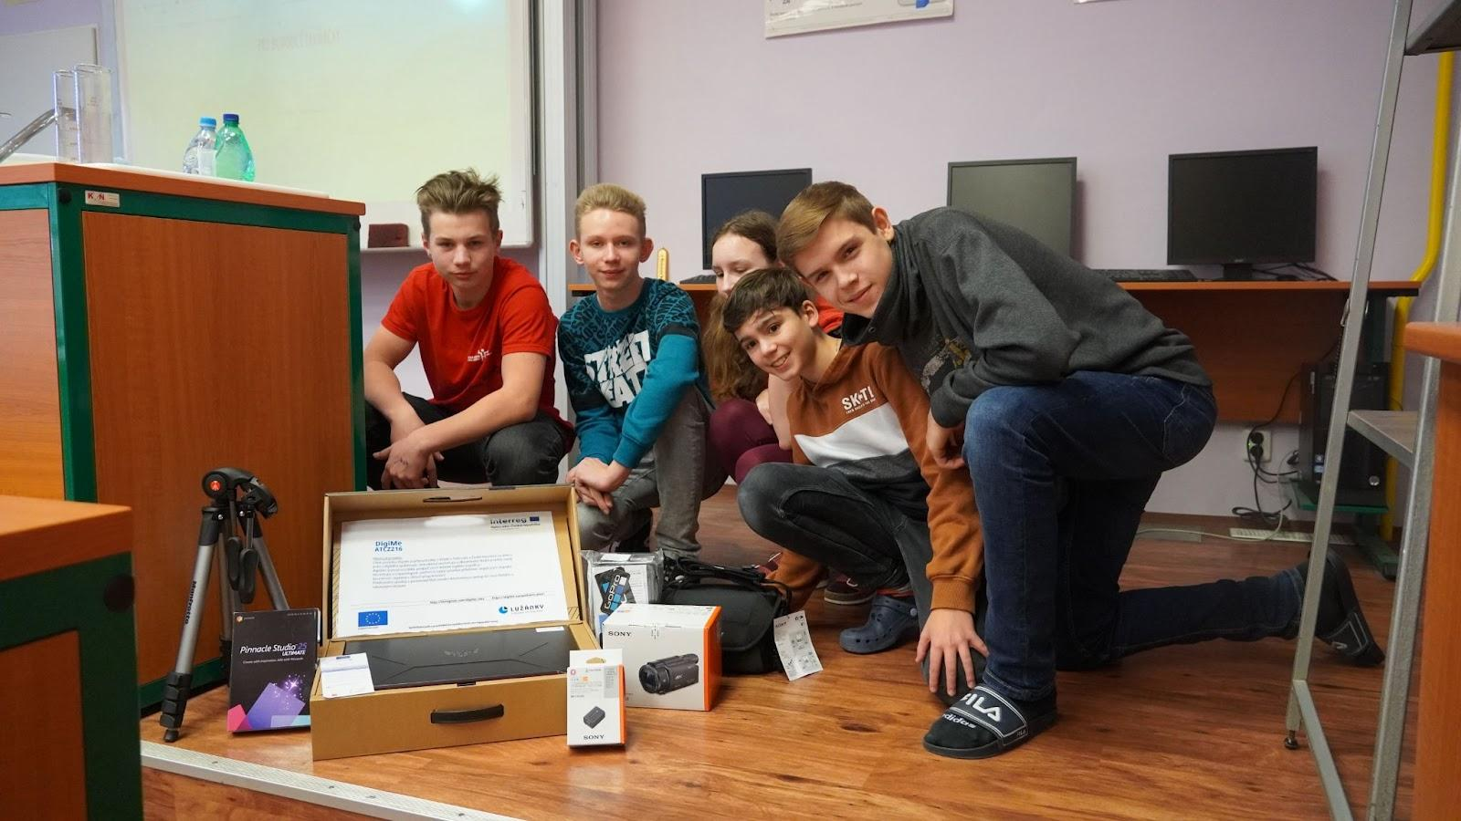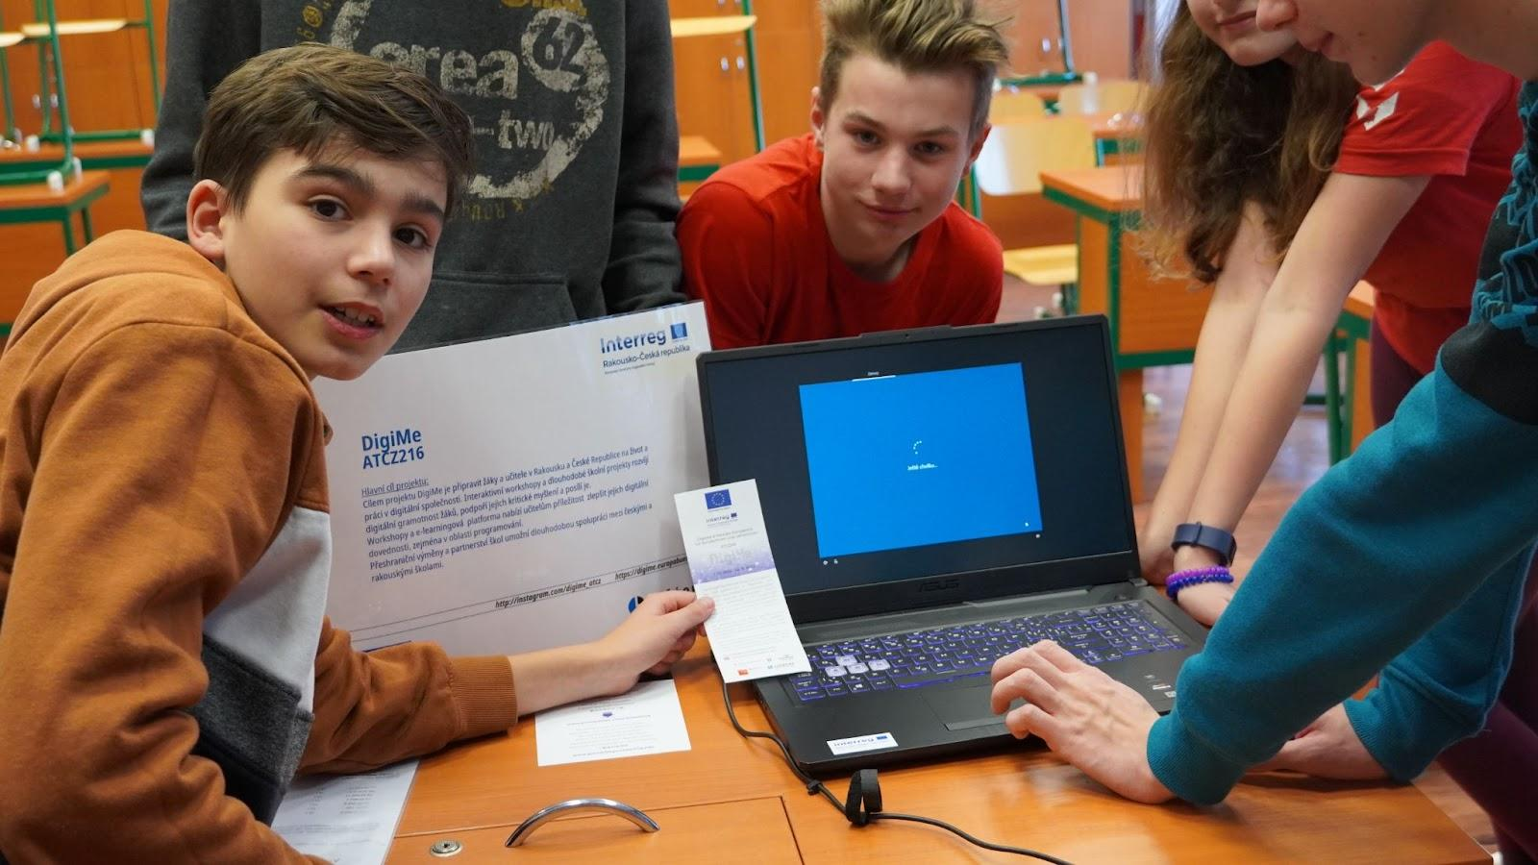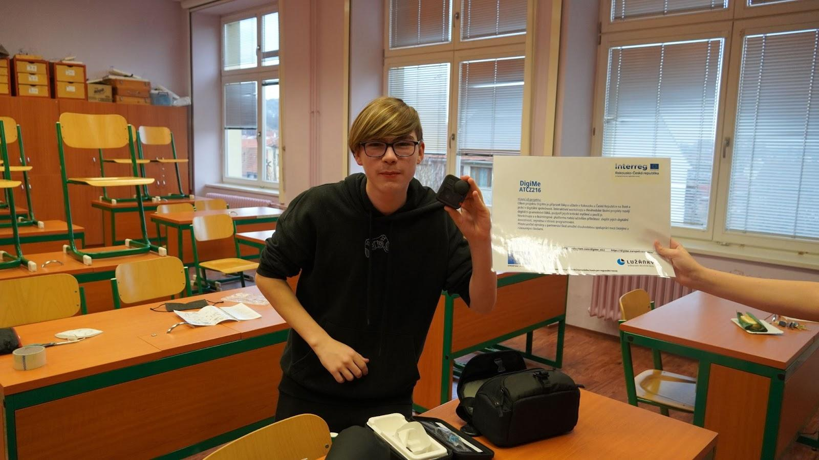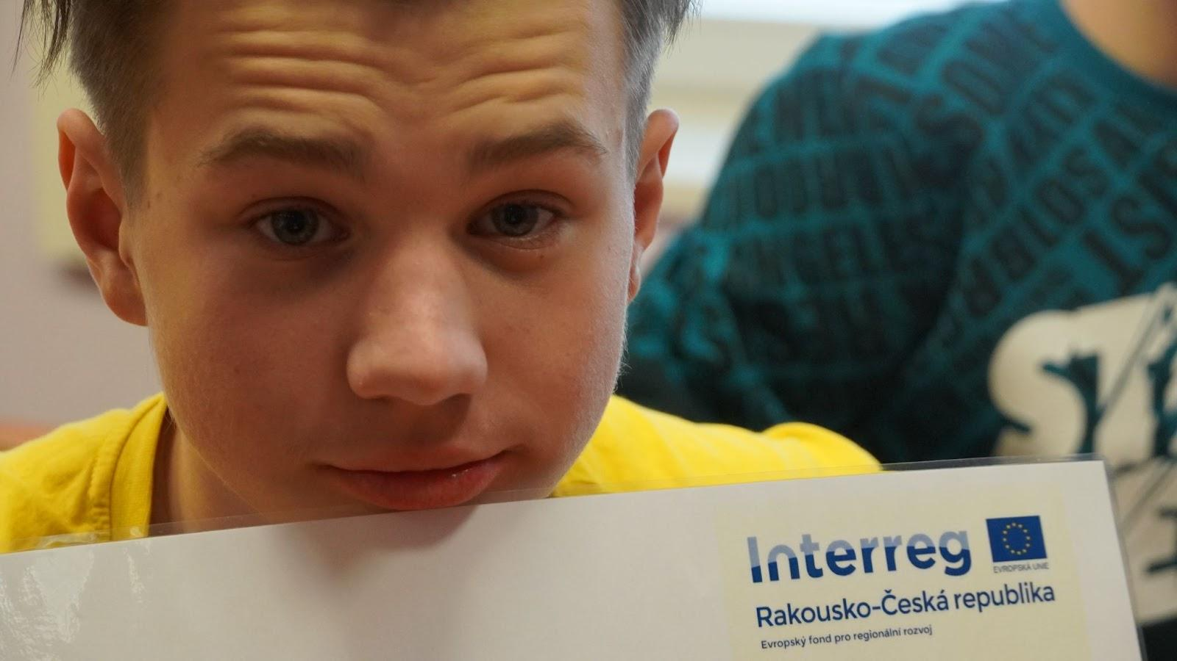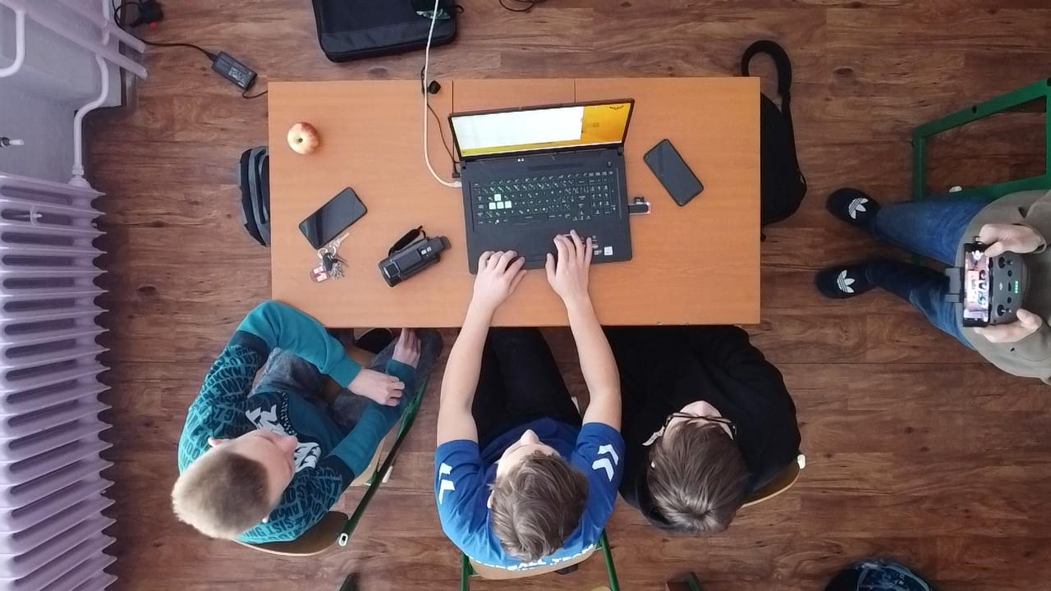
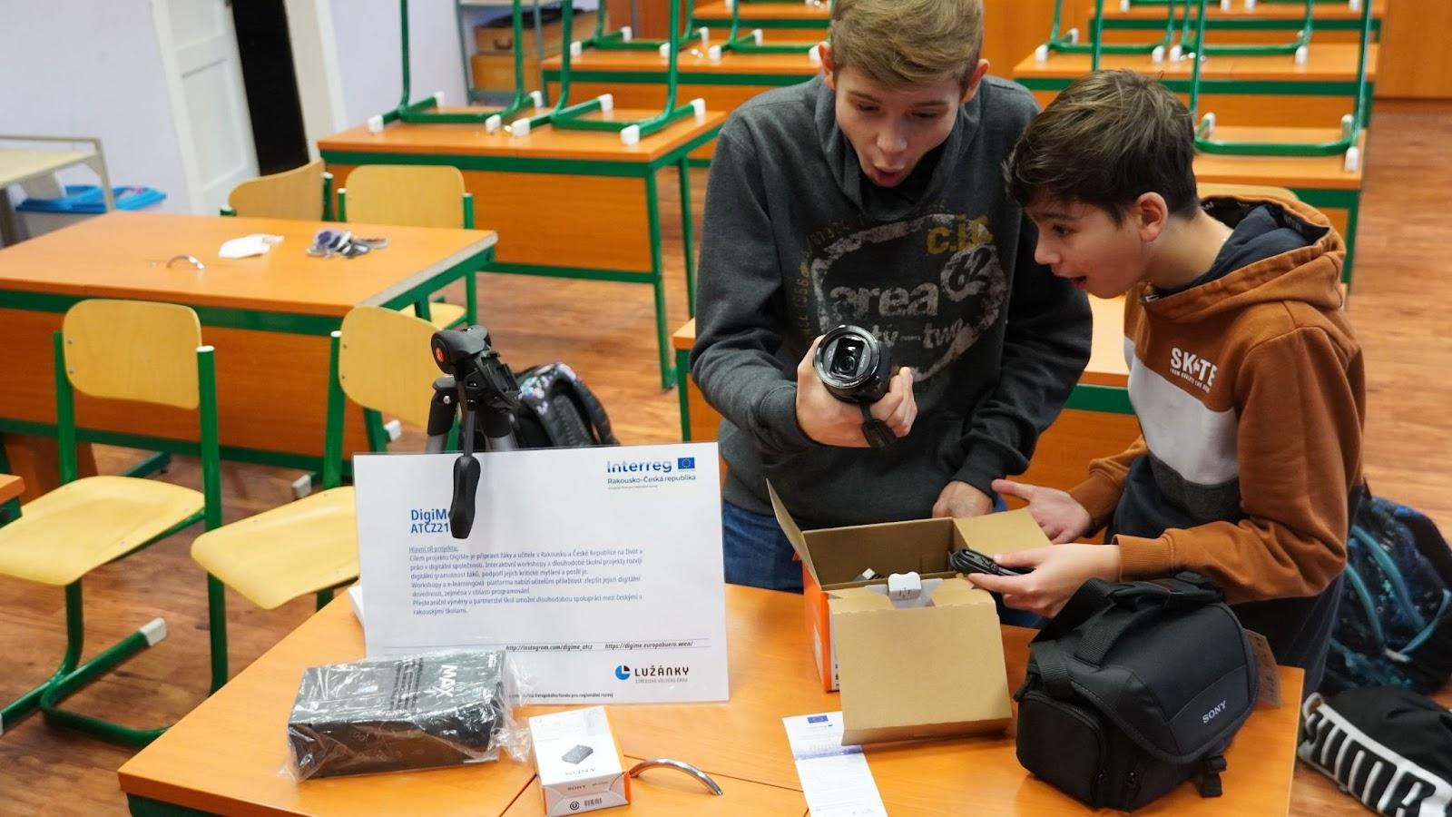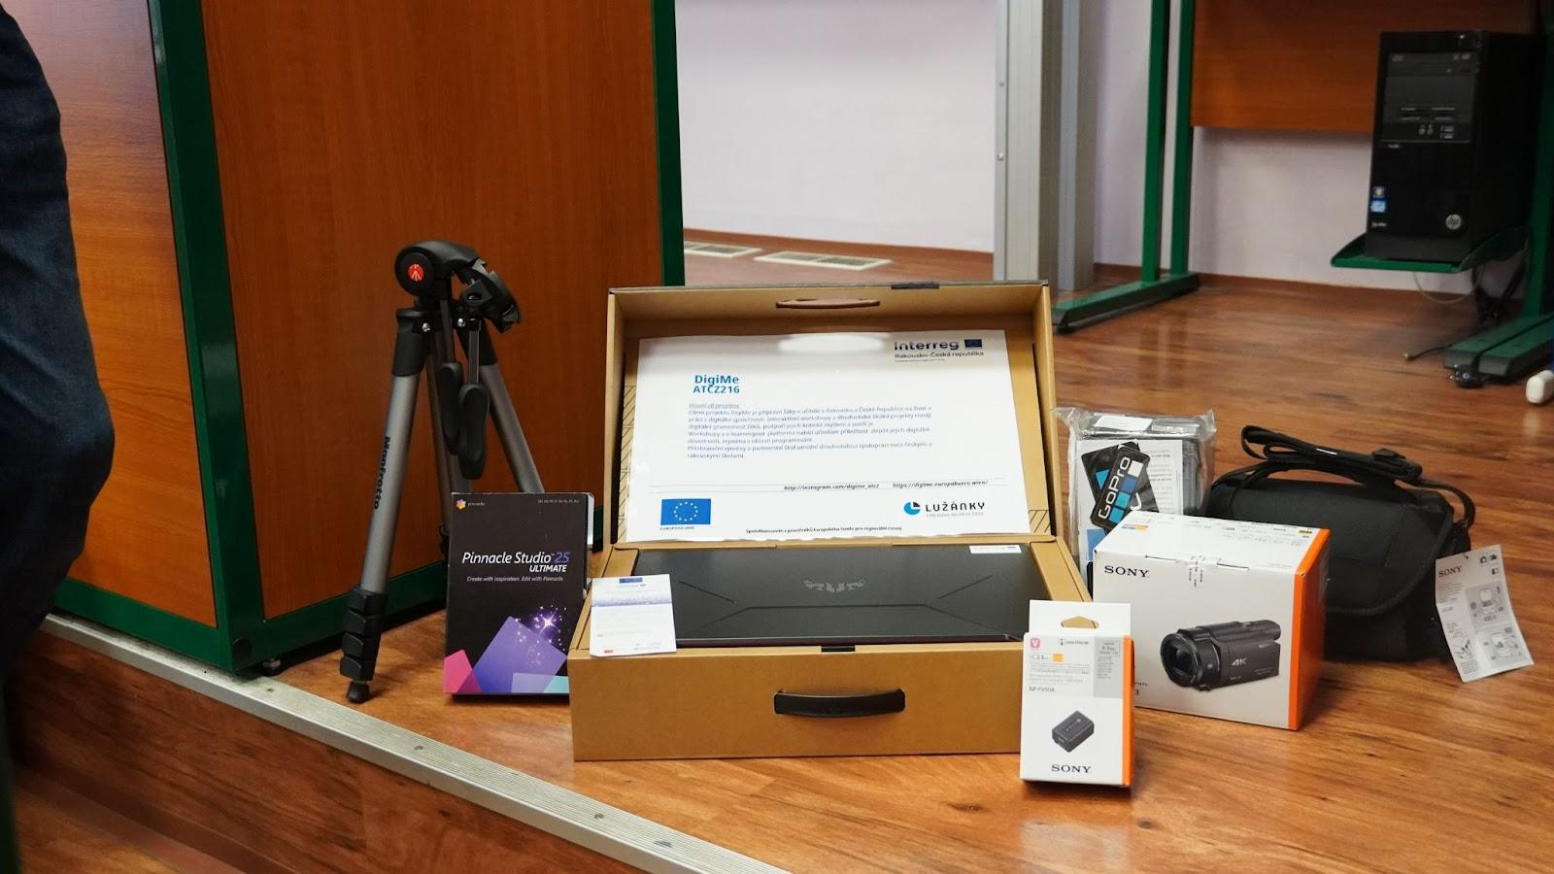
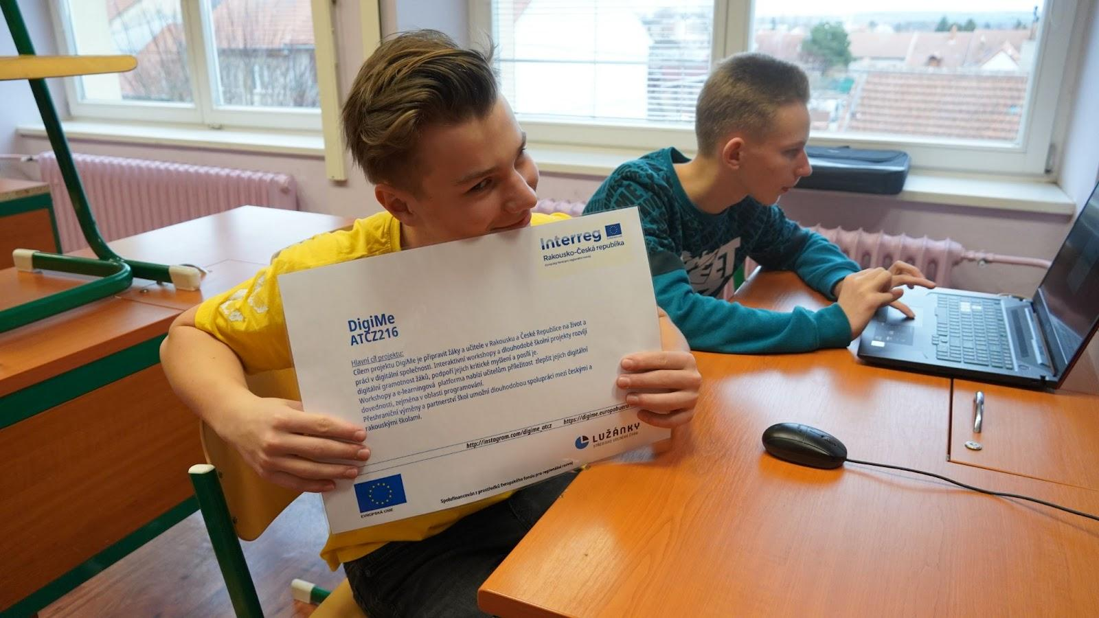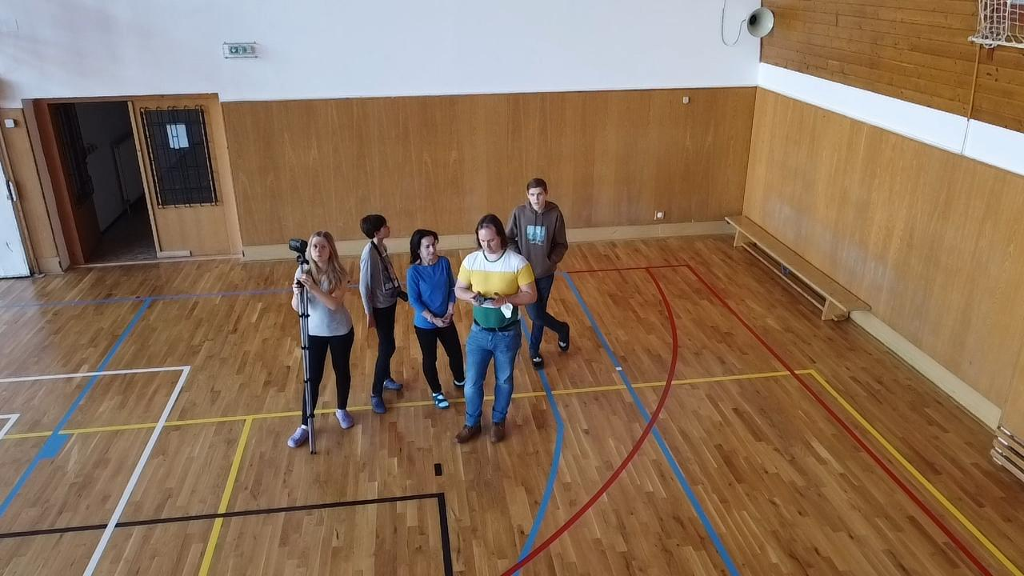

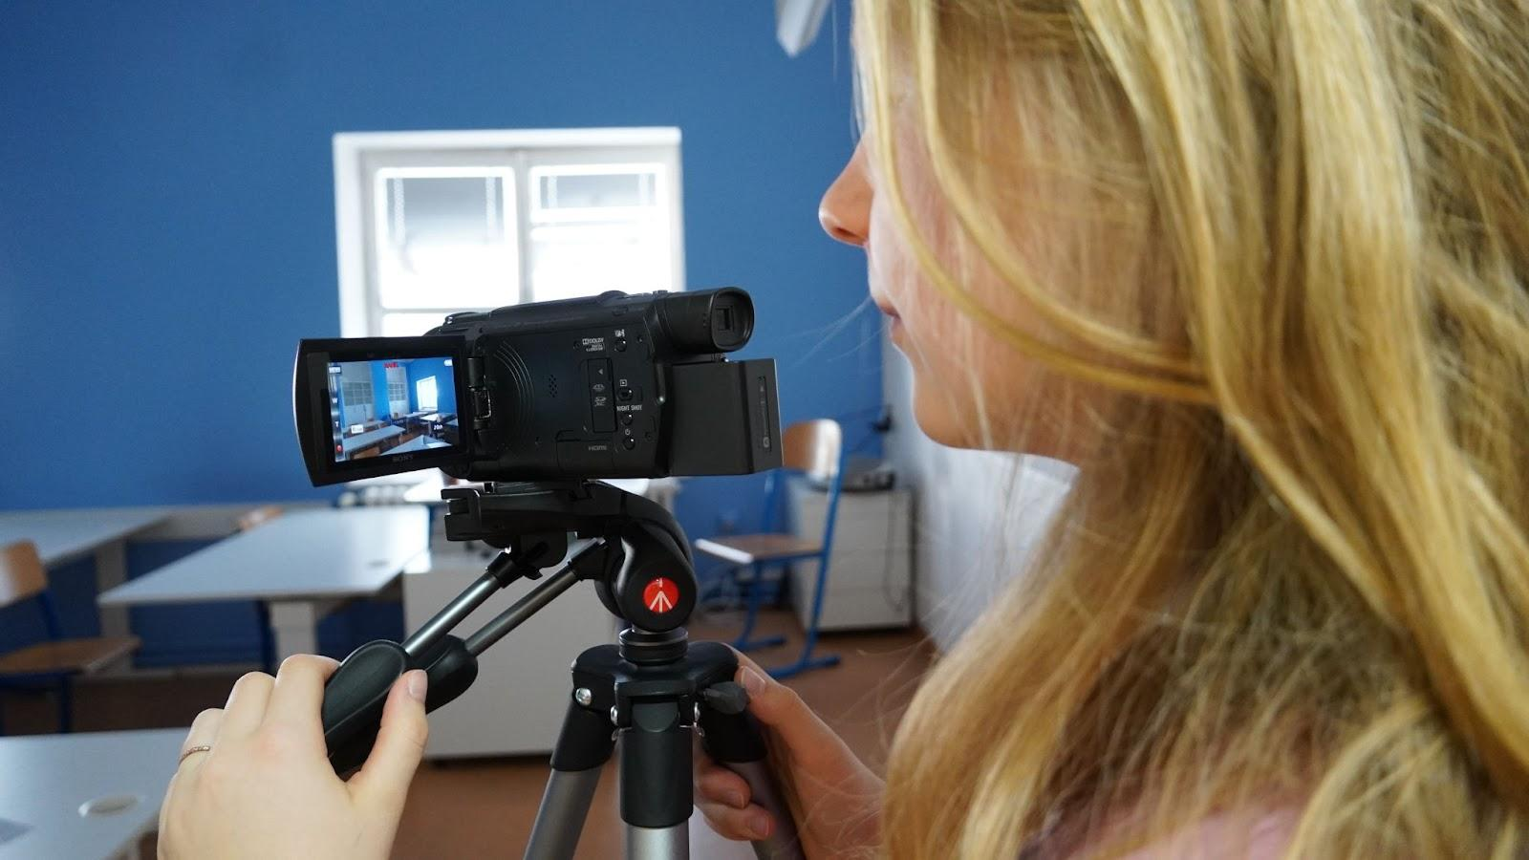
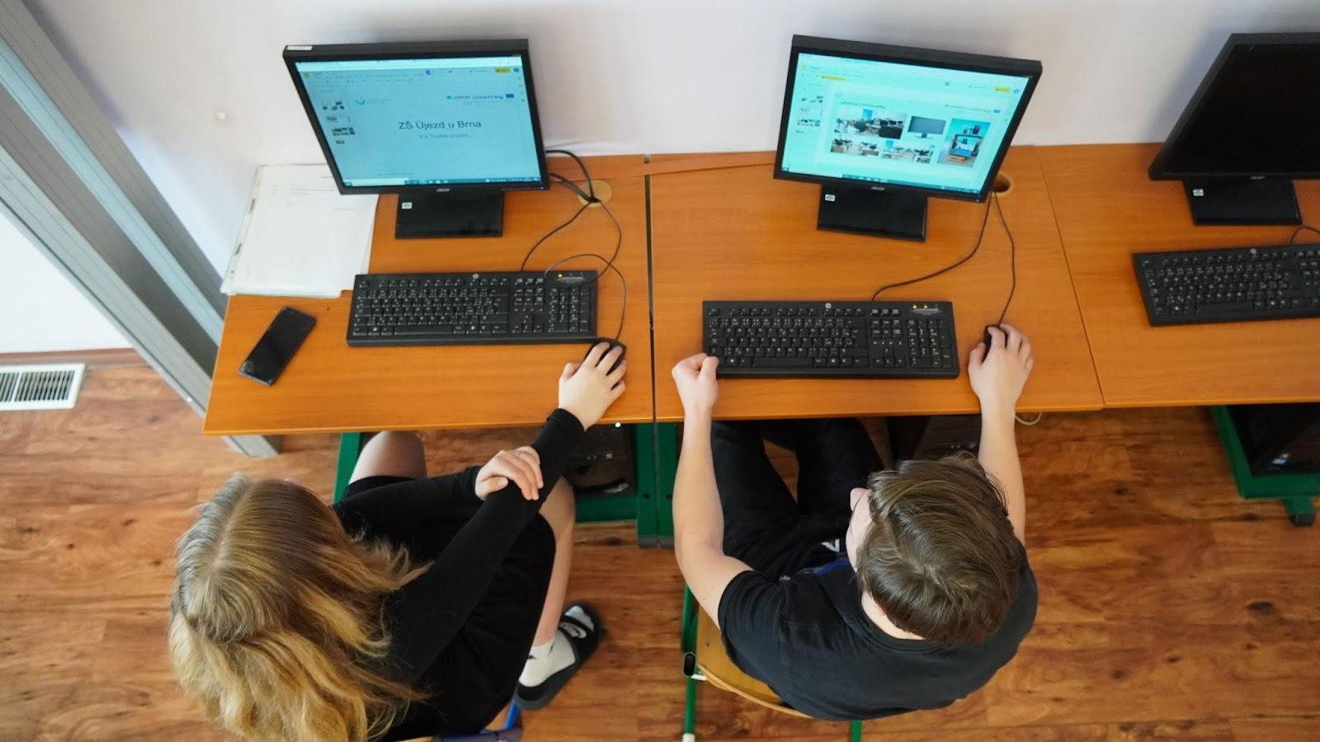

Work in specialised classrooms
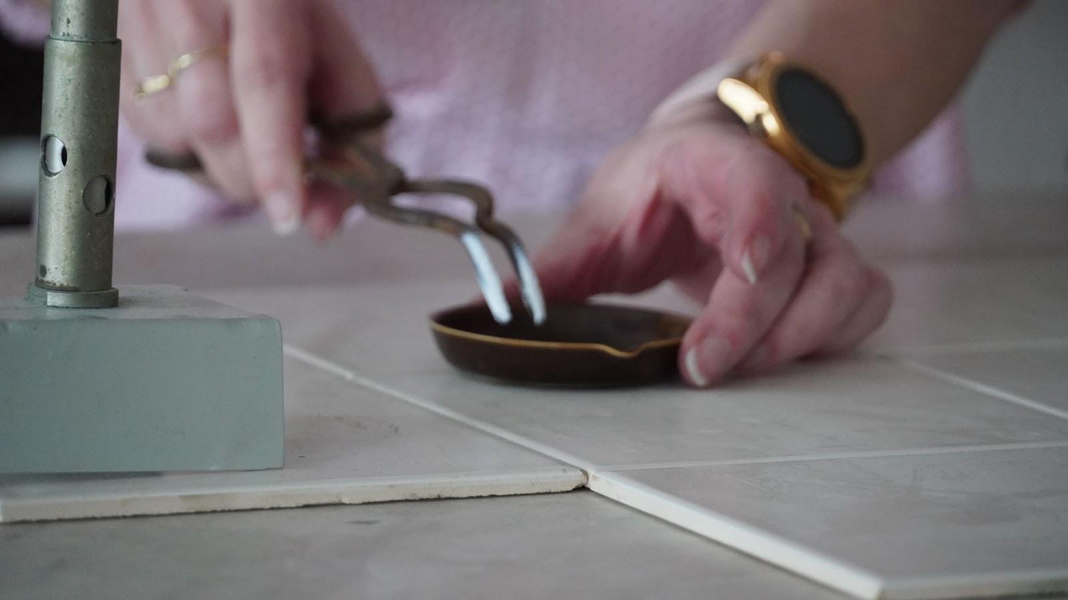
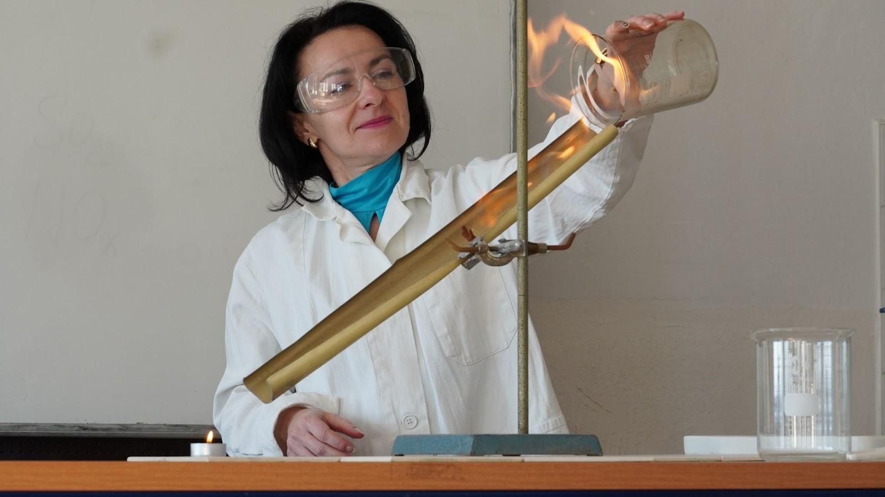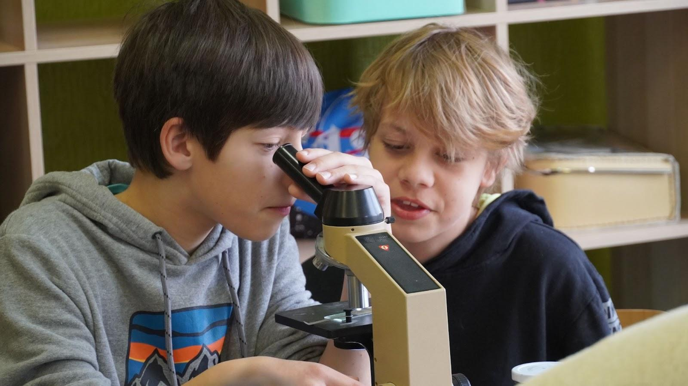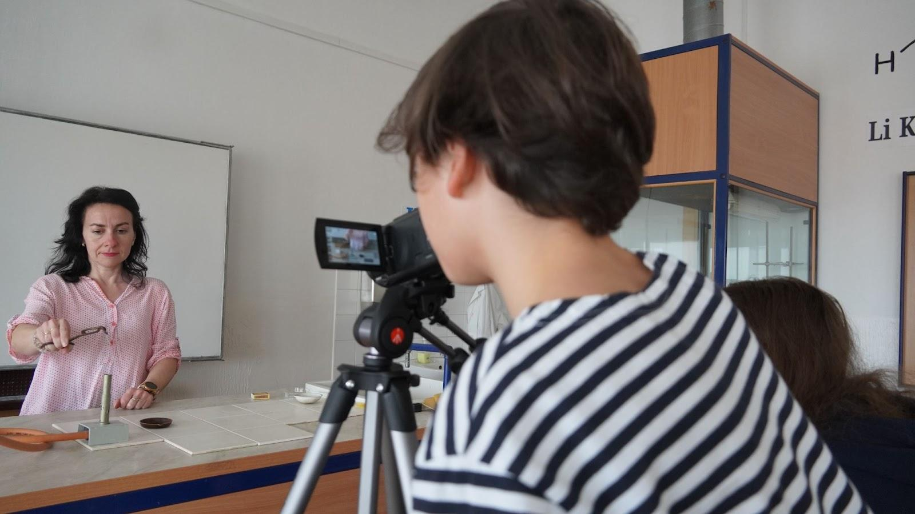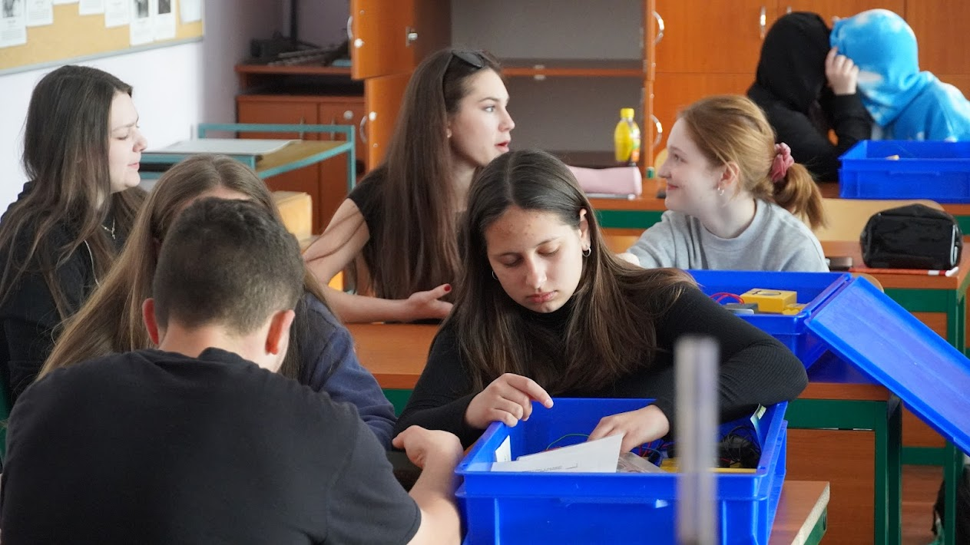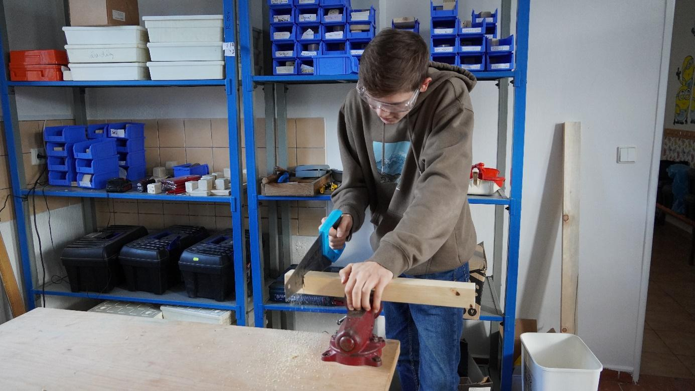

Pinnacle Studio
Pinnacle Studio is a professional editing program. The program worked quite well for us, but we also had some problems. It is more for more experienced and more knowledgeable people in the cutting industry. The content of the project was to create a promo video for our school using a purchased editing program.
First, we got acquainted with this program. Orientation in the program was more complicated. The template for our work was a video from the purchased package, according to which we then started working step by step. The problem for us was the sound, which we spent the most time on. After some research, we managed to solve this problem as well.
Pros: We were very surprised how easy and quick the program was to install. After filling in the login information, we were able to cut right away. The instructional videos were excellent and helped us a lot in our work. Another advantage of the program is: the selection of a large number of transitions, sound adjustments, brightness changes, etc.
Cons: The program was complex and difficult to understand. In our opinion, the program is more suitable for more experienced users in the field of editing.

Evaluation
Even though the project is officially over, it will remain in our hearts for a long time. We can probably all agree that we thoroughly enjoyed it. For that result, all the hard work, all the time, all the flying around school was really worth it. It also contributed to the fact that we gathered a very good group, who thoroughly enjoyed each meeting, and also thanks to our great protectors, the teachers, who happily took care of us and even invited us for lunch:).
I think we can really say out loud:
WE DID IT!

